CHAPTER 3: METHODOLOGY

3.1 SYSTEM REQUIREMENTS
- ESP32 microcontroller.
- DHT11 sensor - Temperature and humidity.
- Mq7 sensor - carbon monoxide(CO).
- MQ8 sensor.
- MQ5 sensor.
- Nova PM sensor.
- Breadboard and stripboard.
- 12 V battery and battery charger.
- Powerbank.
- Buzzer.
- Relay.
- Jumper wires.
- Firebase studio
- Arduino IDE
- Visual studio code
- GitHub
- LCD Display.
- Voltage regulator.

3.2 SYSTEM DEVELOPMENT

3.2.1 Circuit Design and Development
The sensors’ Vcc pin will be connected to the positive terminal (+5V) of the power supply unit (PSU) and the ground pins will be connected to the ground terminal (negative terminal) of the power supply unit. The sensors cannot be supplied by the 5V pin of the ESP32 because the total power consumption of the sensors exceeds what can be supplied by the ESP32’s 5V pin and doing so will overload the onboard voltage regulator that will damage the ESP32 board. This is due to the fact that the MQ series sensors require preheating making them power hungry. The ground pin of the ESP32 and the power supply unit’s ground terminal will be connected together to provide a common ground for the sensors ensuring that the signal values from the sensors are stable and accurate.
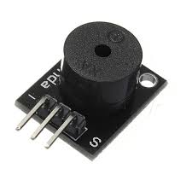  Figure 1:Passive Buzzer | 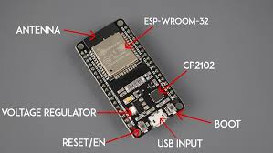  Figure 2: ESP32 Board
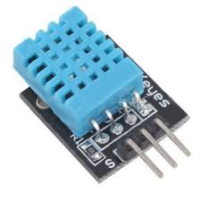  Figure 3: DHT11 Sensor | 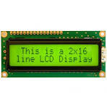  Figure 4: LCD Display
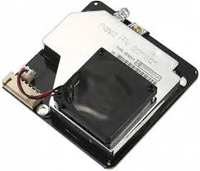  Figure 5: PM nova Sensor | 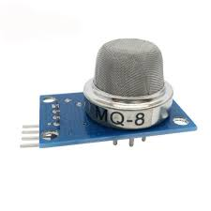  Figure 6: MQ8 Sensor
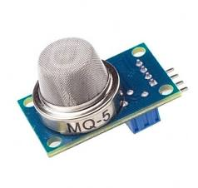  Figure 7:MQ5 Sensor | 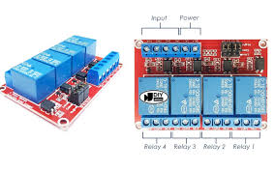  Figure 8: 4_way relay Channel
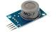  Figure 9: MQ7 Sensor | 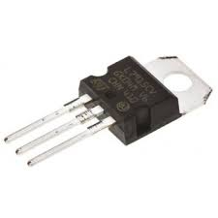  Figure 10: Voltage Regulator

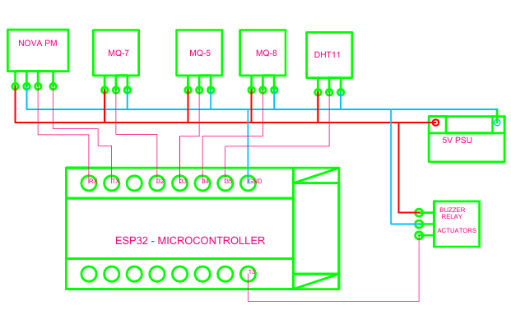
Figure 11: Circuit Connection

3.2.2 Database and Web Development
The real-time database will be developed on firebase studio for storage of the sensor values transmitted from the ESP32 node. The web scripts will be done on visual studio code and configuration keys for the database to enable seamless communication between the database and the web page will be inserted accordingly. The web app will be tested before deploying to the GitHub pages for hosting.

3.2.3 Firmware Development
The program that will enable the ESP32 microcontroller to read values from the sensors, connect to the internet, perform necessary signal processing and package the data for transmission to the firebase database will be developed in Arduino IDE. The configuration keys for the database will be embedded into the program to enable seamless communication between the ESP32 and the firebase real-time database. This program will aid in data collection.

3.3 DATA COLLECTION
The sensors will take readings of the respective air constituents and transmit the values in terms of a voltage signal to the analog pins of the ESP32 board, the signal will therefore be digitized inside the ESP32 using the analog to digital converters (ADCs) inside the ESP32 board. The values will be quantized within a 12-bit range of 0-4095 depending on the strength of the signal received and transmitted via internet to the firebase real-time database for storage. Through HyperText Transfer Protocol (HTTP), the data will be conveyed to the web application for real-time visualization.
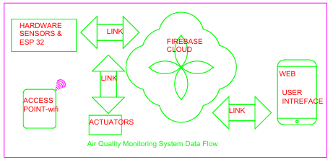
Figure 12: Flow of Data

The data collection exercise will span for a minimum 30 days and all of it will be stored in the firebase database where later it’ll be accessed for analysis. The transfer of the data to the firebase database will occur after every 30 seconds. This is a design property to reduce the number of requests and responses (HTTP protocol) that the ESP32 has to make per unit time during transmission of the data to the cloud based database. This reduces network overhead and improves system stability ensuring the ESP32 doesn’t oveheat and prolongs its life and improves the overall performance of the system.

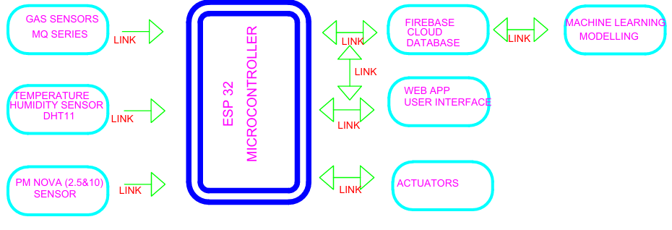
Figure 13: System Block Diagram

3.4 DATA ANALYSIS METHODS
Sensor data will be collected and stored in the Firebase database at a fixed interval of 30 seconds for a minimum duration of 30 days. The total number of data points will be estimated using the expression:
(Days × Hours_In_A_day × Minutes_In_Hour × Seconds_In_minute) ÷30
For a 30-day data collection period, this results in approximately 86,400 data points per sensor.
The collected dataset will be preprocessed to remove missing values, handle outliers, and ensure timestamp consistency before further analysis. The cleaned data will be used to train simple machine learning models aimed at short-term prediction and anomaly detection.

3.4.1 Machine Learning Models
The following machine learning models will be employed in this project:
I. Decision Tree (DT)
Decision Trees are supervised learning algorithms used for both classification and regression tasks. They operate by recursively splitting the input data based on feature values, forming a tree structure where internal nodes represent decision rules and leaf nodes represent output predictions. Decision Trees are easy to interpret, computationally efficient, and suitable for structured sensor data. However, they are sensitive to small variations in the dataset and are prone to overfitting. To reduce this effect, tree depth and splitting criteria will be controlled during training.

II. Random Forest (RF)
Random Forest is an ensemble learning technique that combines multiple Decision Trees to improve prediction accuracy and robustness. Each tree is trained on a random subset of the dataset, and final predictions are obtained through averaging (for regression) or majority voting (for classification). Random Forest models are less sensitive to noise and provide improved generalization compared to individual Decision Trees. Their main limitation is increased computational cost and reduced interpretability due to the ensemble structure.

III. Isolation Forest (IF)
Isolation Forest is an unsupervised learning algorithm designed for anomaly detection. It works by isolating data points through random partitioning, where anomalies require fewer splits to be isolated compared to normal data points. This model will be used to detect abnormal pollution patterns such as sudden gas concentration spikes that deviate from normal operating conditions.

3.4.2 Model Training and Deployment

The collected data will be subdivided in the ratio 80:20 where 80% of the data will be used for the models’ training and the remaining 20% will be used for testing the models. The models’ training will be done locally on the PC and will be run either locally on the PC or remotely on google cloud. The models cannot be run inside the ESP32 board because it’s limited in hardware resources. The predicted values (random Forest, RD) will be displayed on the web dashboard and incase of anomaly detection (Isolation forest, IF) alerts will be triggered on the web dashboard for action.

3.4.3 Model Evaluation Metrics
- Mean Absolute Error (MAE)
MAE measures the average magnitude of errors between the predicted values and the actual sensor readings, ignoring the direction of the errors. It is calculated as the arithmetic mean of the absolute differences between predicted and actual values. A lower MAE indicates that the model’s predictions are closer to the true sensor values, providing a clear measure of average prediction accuracy.
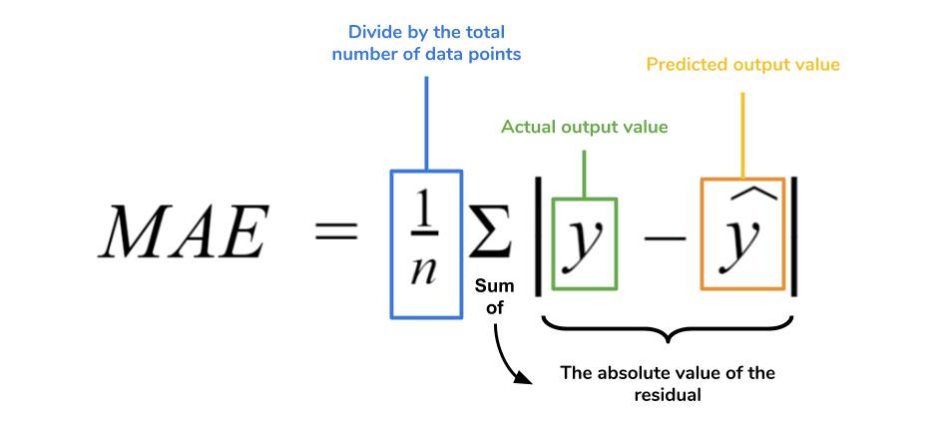
- Root Mean Square Error (RMSE)
RMSE measures the square root of the average squared differences between predicted and actual values:
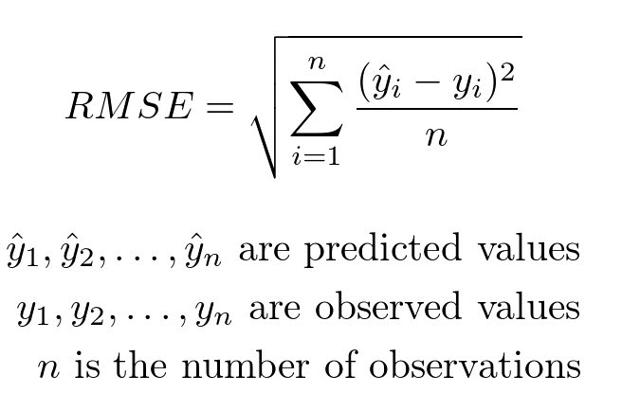

Unlike MAE, RMSE penalizes larger errors more heavily, making it more sensitive to outliers. A smaller RMSE value indicates better model performance and that the predicted values closely follow the actual sensor readings. Together with MAE, RMSE provides a comprehensive view of the model’s prediction accuracy.
- Confusion Matrix
Isolation Forest will be evaluated using a confusion matrix to allow for a detailed assessment of its ability to detect anomalies in air quality. The confusion matrix will record the number of:
- True Positives (TP): abnormal events correctly identified as anomalies
- True Negatives (TN): normal events correctly identified as normal
- False Positives (FP): normal events incorrectly flagged as anomalies
- False Negatives (FN): abnormal events incorrectly classified as normal
From the confusion matrix, metrics such as accuracy, precision, recall, and F1-score will be derived. This evaluation ensures that the Isolation Forest reliably detects abnormal pollution events, such as sudden spikes in gas concentration, while minimizing false alarms.

Start
Firebase Database

Any Pollutant spike?
DHT11 Sensor
ESP32
Board
Gas Sensors
PM Nova Sensor
Is Actuator needed?
Send Alert
On Web App
NO
YES
NO
Activate
Safety Response System
YES
Air Clean
ML Python Server
Figure 14: System Flow Chart

3.5 Prototype Testing
The developed prototype will be tested under both controlled and real-world operating conditions to verify system functionality and performance. Controlled testing will be carried out using simulated pollutant sources to evaluate sensor response, threshold detection, and alert triggering behavior. These tests will be used to confirm correct sensor interfacing, data acquisition, and cloud data transmission. Real-world testing will be conducted in a domestic environment to assess system reliability under normal environmental variations such as temperature changes, ventilation differences, and background pollution levels. Key performance parameters to be evaluated will include sensor responsiveness, alert latency, cloud data update consistency, and web dashboard functionality. The results of these tests will be used to validate that the system meets its intended functional and operational requirements.

3.6 Ethical and Safety Considerations
- Gas sources used during controlled testing are handled in well-ventilated environments to minimize the risk of accidental exposure.
- Testing procedures are designed to ensure that no individuals are exposed to hazardous gas concentrations at any stage of system evaluation.
- The system collects only environmental sensor data for research and performance evaluation purposes. No personal or sensitive user data is recorded, and access to stored data is restricted to authorized users.

